WORKING ALONE OR IN ISOLATION RISK ASSESSMENT FORM AND GUIDE
Supervisor or Manager /Head of Department
Unit of Study or Research Project
Work Description
Proposed Dates
Transport Arrangements (where applicable)

Communication Strategy
University or other reputable contact
Frequency or schedule of contact
Primary means of communication
Secondary means of communication( if required)
Action should contact not be made in accordance with the above

Itinerary ( Please provide an attachment if necessary )
Dates /times | Location | Accommodation | Contact details
Please refer to the attached

Primary checklist ( Fieldwork Leader to complete) | Tick
Employees and /or students have or will be briefed on the details of the work and all relevant safety policies , procedures and codes of conduct
All equipment, vehicles and tolls have been checked for safe operation prior to the work
I have made all necessary arrangements for the effective management of emergencies that may arise in all the course of the work

Emergency contact Number
Campus Security | 085 -443930 or 085 - 443999
Miri Police Station (Headquarters) | 085 -432222
Miri General Hospital | 085- 420033
Miri Fire Service and rescue Department | 994 / 085-420991

Working Alone Risk Assessment

GENERAL INFORMATION
Fieldwork Activity / Task : | Location:
Fieldwork Activity / Task : | Date :
 |  |  | Risk Rating |  |  |  | Risk Rating
Activity | Potential Hazards | Current Controls | L | S | R | Risk Control Measures  Elimination (EL),e.g.: eliminate task, remove hazard  Substitution (SU)e.g. : replace task or hazardous process  Isolate (IS)e.g. : enclosures, restricted access  Engineering (EN) e.g. : guarding, separation, redesign  Administrative (AD) e.g. : Safe Work Procedures  Personal Protective Equipment (PPE) e.g. : Gloves, goggles | L | S | R | Person Responsible | Date Completed
BIOLOGICAL HAZARD IDENTIFICATION
OPERATIONAL HAZARD IDENTIFICATION
DIVING RELATED HAZARD IDENTIFICATION

Working Alone - Health and Safety Risk Matrix
Determining the risk level: Risk Level = Likelihood x Severity
Likelihood Rating Table
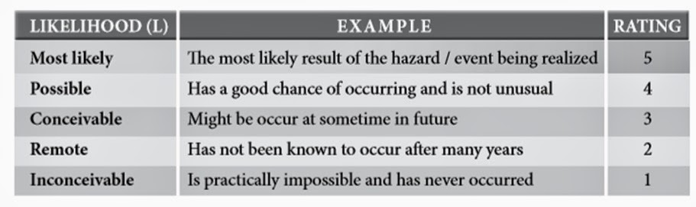

Severity Rating Table
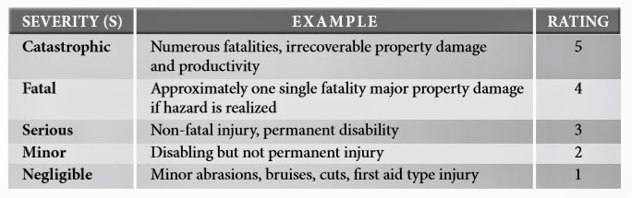
Source: Ministry of Human Resource, Malaysia, 2008
(Guidelines for Hazard Identification, Risk Assessment and Risk Control)

Risk Assessment Matrix Table
 | SEVERITY (S)
LIKELIHOOD (L) | 1 | 2 | 3 | 4 | 5
5 | 5 | 10 | 15 | 20 | 25
4 | 4 | 8 | 12 | 16 | 20
3 | 3 | 6 | 9 | 12 | 15
2 | 2 | 4 | 6 | 8 | 10
1 | 1 | 2 | 3 | 4 | 5

RISK | DESCRIPTION | ACTION
15 – 25 | HIGH | A HIGH risk requires immediate action to control the hazard as detailed in the hierarchy of control. Actions taken must be documented on the risk assessment form including date for completion.
5 – 12 | MEDIUM | A MEDIUM risk requires a planned approach to controlling the hazard and applies temporary measure if required. Actions taken must be documented on the risk assessment form including date for completion.
1 – 4 | LOW | A risk identified as LOW may be considered as acceptable and further reduction may not be necessary. However, if the risk can be resolved quickly and efficiently, control measures should be implemented and recorded.
Source: Ministry of Human Resource, Malaysia, 2008
(Guidelines for Hazard Identification, Risk Assessment and Risk Control)

…………………………………………………. ……………………………………………
Prepared By: Approved by Supervisor:

