Project Leader | Position | Project Team Members | Project Title
  Dr. Lynn Ling Yew Hua | Lecturer  Accounting and Finance  Faculty of Business | 1. Dr. Tanusree Chakravarty Mukherjee  2. Wendy Law Li Ling  3. Khin Than Myint | Accounting Students' Perceptions of Gamified Learning Platform: A Teaching Innovation
  Abirami A/P Sashidharan | Associate Teaching Fellow  WIL and Language Department  School of Pre-U and Continuing Education |  | Tune, Talk, Triumph: Enhancing Academic English Skills on Spotify’s Global Stage
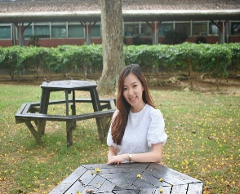  Dr. Ting Qian Hui | Lecturer  Management and Marketing  Faculty of Business | Dr. Fayrene Chieng Yew Leh | Thrive Together: A Journey Towards Achieving Student Well-being
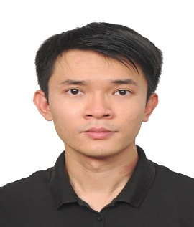  Dr. Timothy Ting Zhi Hong | Senior Lecturer  Civil & Construction Engineering Department  Faculty of Engineering and Science | 1. Dr. Lee Yeong Huei  2. Dr. Tina Ting Chui Huon  3. Ts. Dr. Paran anak Gani  4. Ir. Dr. Tan Yee Yong  5. Dr. Tay Ai Chen  6. Dr. Lai Wai Yan  7. Dr. Tan Yin Ling  8. Dr. Yong Leong Kong | Fostering Student-Supervisor Interactions: Leveraging WhatsApp Stickers to Enhance Engagement in Final Year Research Projects
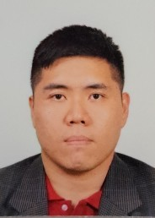  Dr. Tan Yee Yong | Senior Lecturer  Civil & Construction Engineering Department  Faculty of Engineering and Science | Ir. Meheron Selowara Joo | Implementing the Universal Design for Learning (UDL) Framework in Engineering Ethics Component of the Civil and Environmental Engineering Programme
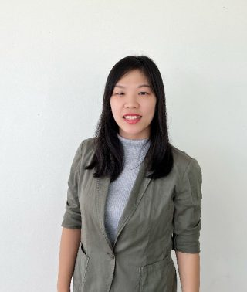  Dr. Ho Jie Min | Lecturer  Management and Marketing  Faculty of Business | - Yip Ka Yii  - Dr. Ivy Hii Siaw Hung | Transforming Learning Through Establishing a Student-Powered Market Research Consulting Agency
  Dr. Muhammad Usman | Lecturer  Management and Marketing  Faculty of Business | 1. Prof. Pauline Ho Poh Ling  2. Assoc. Prof. Lew Tek Yew  3. Dr. Muhammad Imram Tanveer Opel  4. Dr. Mohammad Abdul Matin Chowdhury | Enhancing Student's Wellbeing: A Study of Challenges and Opportunities in Higher Education Institutes
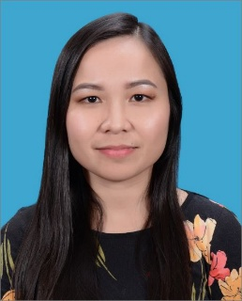  Esther Puyang Lihan | Teaching Fellow  Science and Technology Department  School of Pre-U and Continuing Education | 1. Kamaroizan Mohamad  2. Donna Peterus | Real-Time Collaboration with FigJam and Visual Studio Code (VSC) Live Share to Enhance Student Engagement and Workforce Readiness
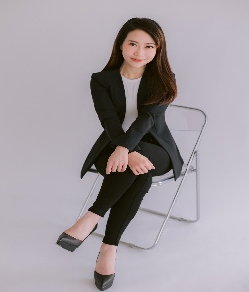  Yip Ka Yii | Lecturer  Accounting and Finance  Faculty of Business | 1. Dr. Ho Jie Min  2. Assoc. Prof. Ir. Dr. Lim Chye Ing  3. Dr. Ivy Hii Siaw Hung | Beyond the Classroom: Enhancing Student Learning Experience, Motivation and University Engagement Through Collaborative Industry Partnerships
  Shubashini A/P Krishnan | Teaching Fellow  Science and Technology Department  School of Pre-U and Continuing Education | 1. Carrie Ho Lee Ing  2. Jameson Malang  3. Bejay Ugon  4. Puteri Nurul Fatihah Binti Mohamad Azli | Making Mathematics Relevant: Incorporating Guest Speakers and Students as Partners
  Dr. Ivy Hii Siaw Hung | Lecturer  Accounting and Finance  Faculty of Business | 1. Dr. Ho Jie Min  2. Jameson Malang | From likes to learning: Investigating the role of social media in shaping instructor credibility and student engagement
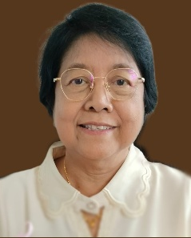  Khin Than Myint | Lecturer  Accounting and Finance  Faculty of Business | 1. Wendy Law Li Ling  2. Dr. Lynn Ling Yew Hua | Enhancing Student Engagement Through Innovative Redesigned Assessments: Fostering Collaboration, Diversity, and AI Integration in Higher Education
  Assoc. Prof. Ir. Dr. Lim Chye Ing | Associate Dean of External Engagement,  Associate Professor  Mechanical Engineering Department  Faculty of Engineering and Science | Dr Fethma M Nor | Improving Teaching of Configuration Design of Parts in MCEN4011 through Experiential Learning
  Dr. Joseph Sia Kee Ming | Senior Lecturer  Management and Marketing  Faculty of Business | Dr. Ivy Hii Siaw Hung | The impact of ChatGPT on student engagement and class attendance: A three-dimensional student engagement framework approach
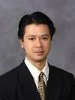  Assoc. Prof. Dr. Goi Chai Lee | Associate Professor  Management and Marketing  Faculty of Business |  | From Blocks to Brains: Exploring the Role of A Lego Game in Developing Agile Thinking in An Educational Setting
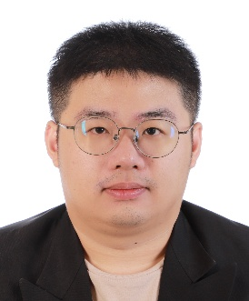  Dr. Lai Wai Yan | Lecturer  Environmental Engineering  Civil & Construction Engineering Department  Faculty of Engineering and Science | 1. Dr. Lee Yeong Huei  2. Ts. Dr. Paran Ak Gani  3. Ir. Dr. Tan Yee Yong  4. Dr. Tina Ting Chui Huon  5. Dr. Tay Ai Chen  6. Dr. Timothy Ting Zhi Hong  7. Dr. Tan Yin Ling  8. Dr. Yong Leong Kong  9. Dr. Kyaw Myo Aung | Application of Discord to Support First Year Engineering Student Learning and Engagement
  Dr. Tanusree Chakravarty Mukherjee | Lecturer  Accounting, Finance & Economics  Faculty of Business | 1. Dr. Malini Sathappan  2. Dr. Ting Qian Hui | Combating Academic Misconduct in the Age of AI: Innovative Teaching Pedagogy for Postgraduate Management Education
  Dr. Kyaw Myo Aung | Lecturer  Mechanical Engineering Department  Faculty of Engineering and Science | 1. Dr. Lee Yeong Huei  2. Dr. Nurul Amira Binti Mohd Ramli | Interactive Guided Learning with Generative AI for Engineering Mechanics Students
  Dr. Tay Ai Chen | Senior Lecturer  Civil & Construction Engineering Department  Faculty of Engineering and Science | 1. Lai Zhen Yue  2. Pang Po Keen  3. Ts. Dr. Paran Ak Gani | Flora survey in Student Fieldwork Learning by Developing Software Application in Smartphone
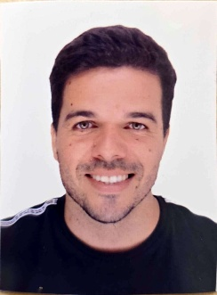  Miguel Guimaraes Barros De Sa | Lecturer  Faculty of Humanities and Health Sciences | Dr. Mitshel Lino | Relationship between Social Media Use, Depression and Anxiety Levels, and Academic Performance in Curtin University – Malaysia students
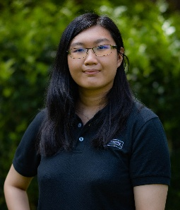  Chong Yu | Associate Teaching Fellow  WIL and Language Department  School of Pre-U and Continuing Education | Terry Justin Dit | Personalized Insights: AI Co-Grading for Enhanced Student Feedback and Growth
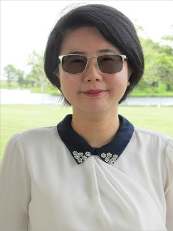  Dr. Mitshel Lino | Lecturer  Faculty of Humanities and Health Sciences | 1. Dr. Joseph Sia Kee Ming  2. Dr. Voltisa Thartori | The impact of social isolation among first-year international university students on group assessment

