Project Leader | Position | Project Team Members | Project Title
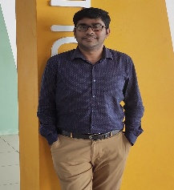  Dr. Sivaraman Eswaran | Senior Lecturer  Computing (Cyber Security) Electrical & Computer Engineering Department  Faculty of Engineering and Science | Dr. Reza Ryan  Dr. Wong Wei Kitt  Foad Motalebi | A Gamified Experiential Learning Model for Mastering Penetration Testing with VulnHub VMs
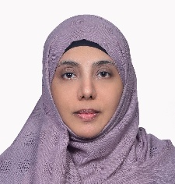  Dr. Ahlam Khaled Mohammed Al-Dhamari | Lecturer  Electrical & Computer Engineering Department  Faculty of Engineering and Science | Dr. Mohammed Sultan Ahmed Mohammed  Dr. Saaveethya Sivakumar | Grokking Object-Oriented Programming in Java through Project-Based Learning and Real-World Application
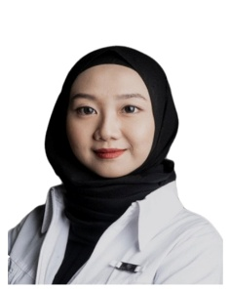  Dr. Hana Chen Wei Jun | Senior Lecturer  Public Health  Faculty of Humanities and Health Sciences | Prof. Roy Rillera Marzo  Dr. Voltisa Thartori  Miguel Guimaraes Barros De Sa | Universal Design for Learning Approach in Enhancing Inclusion in Interprofessional Education among First-Year Allied Health Students
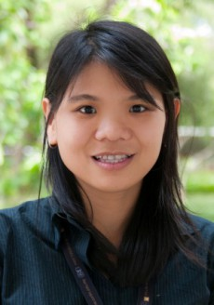  Hii Kiew Ling | Senior Teaching Fellow  Science and Technology Department  School of Pre-U and Continuing Education | Dr. Chew Ing Ming  Lai Zhen Yue | Improving Knowledge Retention and Practical Circuit Skills through Early Exposure and Guided Peer Support
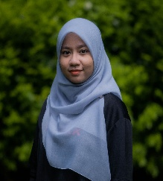  Puteri Nurul Fatihah Binti Mohamad Azli | Associate Teaching Fellow  Science and Technology Department  School of Pre-U and Continuing Education | Jameson Malang  Dr. Anita Jimmie  Fifi Liew Ee En | Math Enhancement Camp: Boosting Confidence and Scores in Mathematics
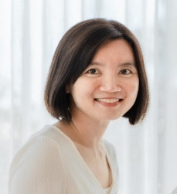  Dr. Evelyn Chiong Tung | Lecturer  Chemical & Energy Engineering  Faculty of Engineering and Science | Dr. Angnes Tiong Ngieng Tze  Dr. Jibrail Kansedo | Enhancing student learning via site visit – bridging industry-academia gap
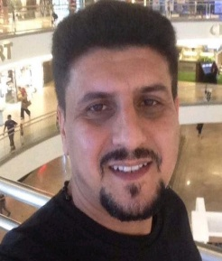  Dr. Haider Hamad Ghayeb | Lecturer  Civil & Construction Engineering Department  Faculty of Engineering and Science | Dr. Yong Leong Kong | Enhancement of Learning and Teaching for Structural Engineering Units Using Mola Structural System
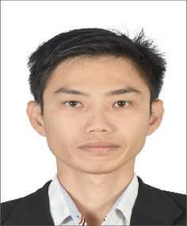  Dr. Yong Leong Kong | Lecturer  Civil & Construction Engineering Department  Faculty of Engineering and Science | Assoc. Prof. Wong Kwong Soon  Dr. Dominique Dodge-Wan  Dr. Hayder Hasan Abdullah | Enhancing Student Learning Experience through Field Trip
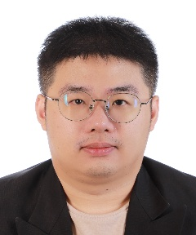  Dr. Lai Wai Yan | Lecturer  Civil & Construction Engineering Department  Faculty of Engineering and Science | Dr. Yong Leong Kong  Dr. Paran anak Gani | Development of Experiential Learning on Green Building through Site Visit & Guest Lecture
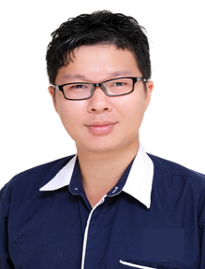  Pang Po Ken | Lecturer  Electrical & Computer Engineering Department  Faculty of Engineering and Science | Prof. Dr. Garenth Ling King Hann  Assocs. Prof. Dr. Raymond Chiong Choo Wee  Dr. Siaw Teck Ung  Lai Zhen Yue | Empowering ETEN 1000 Electronics through Interactive TinkerCAD Classroom

